Project Tasks list
The requirements:
- Select your project or one of the following projects and complete the task.
- Insert your Name and Student ID into the comment line of your M-file's or your GUI figure.
- Write a report of Design, Implementation and testing of the Project selected by you. Use the given template Appendix A-Project report template.doc.
- Zip *.fig, *.m, and report in a file named your student's ID such as LS1925***.zip and submit online.
- Please complete the project by yourself independently, and duplication is not allowed. Copying and being copied will be punished.
- The submit deadline: Nov 26. 2019

Project 1
Group the two numerical methods Composite Simpson Rule and Bisection into one GUI application to show the method. .
(1) It can approximate integration of f(x) with Composite Simpson Rule, when input the f(x) expression, lower limit, upper limit, and set the number of subintervals M=12. The approximate result will show in the text-box. After the execution of the GUI application, it plots the curve of the integral function f(x) and the subintervals in different color.
(2) It also can find out the approximate value of the root of f(x) = 0 and display the root value near the root point.
(5) The GUI initial Layout and it's running cases are shown below.
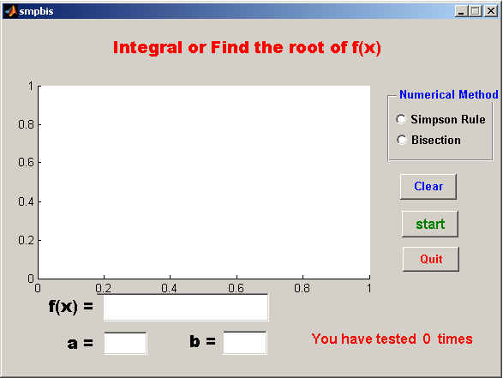
Figure 1 The initial layout
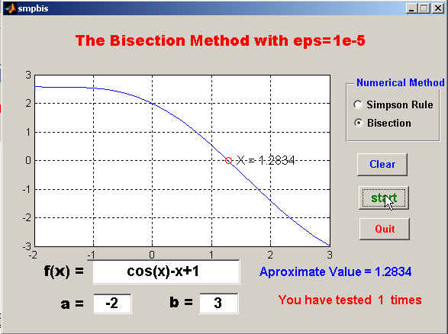
The title changes to the suitable one.
Plot a circle marker and display the value of x title changes to the suitable one.
Figure 2 Select the Bisection method
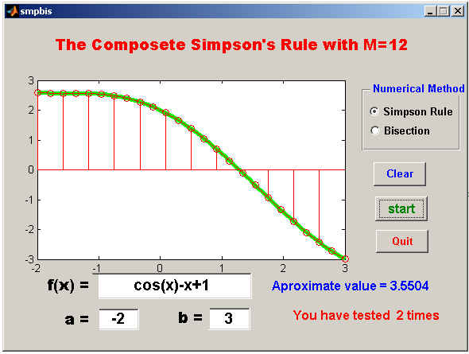
Figure 3 Select the Simpson Rule
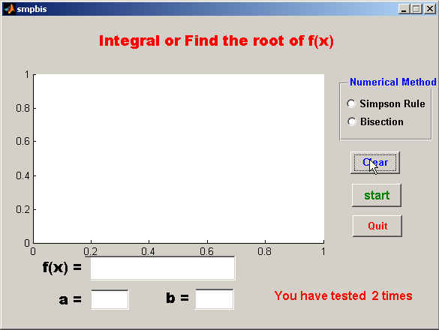
Turn back the original title.
Display the times that you tested
Figure 4 Click Clear button

Project 2
Design and implement a GUI application which use ginput() function to get the selected points and Least Squares Polynomial to fit these points.
After fitting, Plot the polynomial curve and display the P(x) at the top of the axis.
The GUI layout and it's execution figure are shown below.
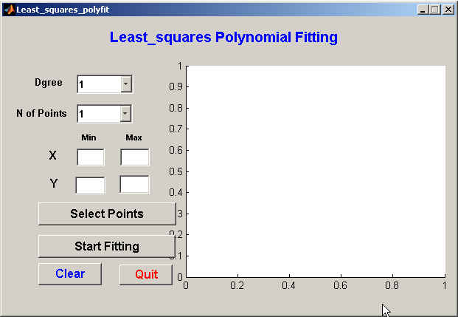
Figure 5 The initial layout
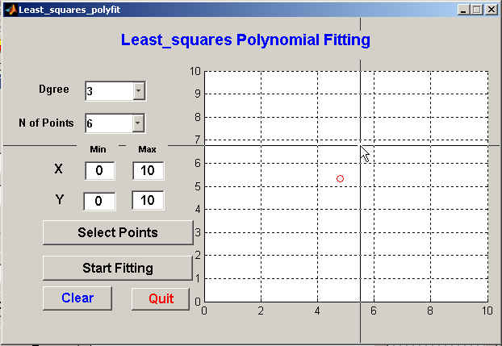
Figure 6 Starting select the points
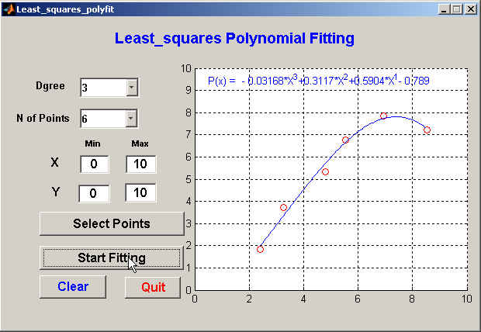
Plot the curve and display the P(x)
Figure 7 Start fitting and plot the result
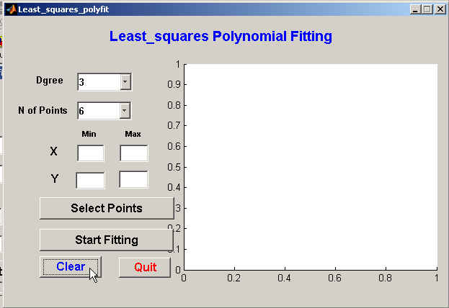
Figure 8 Click the Clear button.

Project 3
Design and implement a GUI application program to simulate an arithmetic calculator, which can do addition, subtraction, multiplication and division of two numbers, and it has CE , Back, M+ ,MR ect. buttons. The layout is shown in the figure 9. Or a scientific Calculator as figure 10.

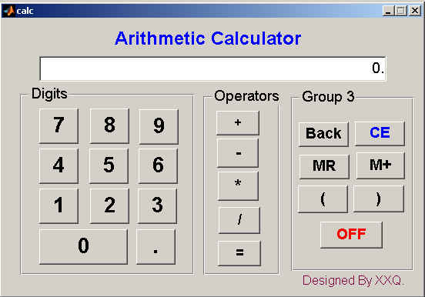

Figure 9 The layout of an arithmetic calculator
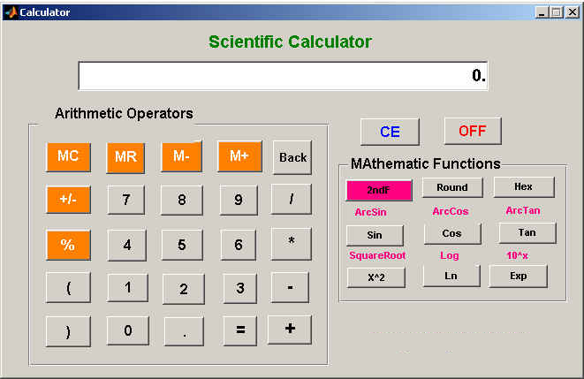
Figure 10 The layout of scientific calculator
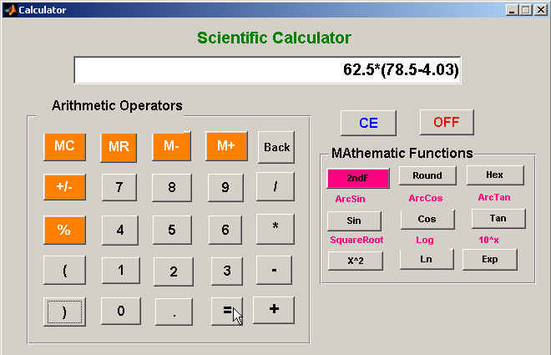
Figure 11 Before clicking the '=" button
The Functions of each button:
Digits buttons represent the digit.
Operator buttons represent the arithmetic operations.
(1) + : plus, - : minus, * : multiplication, and / : division.
(2) Equal sign (=) : press the equal sign (=), evaluate the expression and display the result in the edit box.
Buttons in group 3 :
- Back : when click the 'Back button, Delete one character which is previously typed in.
- CE : initialize the calculator.
- M+ : sum up the currently evaluated value to the summation, and save it into the special memory for later recalling.
- M- : Subtract the currently evaluated value from summation, and save it into the special memory for later recalling.
- MR : recalls the summation and display it in the edit box.
- MC : Clear the Summation.
- OFF : Stops the GUI and close the figure window.
- Sin, Cos, and Tan in degree.
- Hex : converts the decimal integer number to hexadecimal number.
- Round : round the real number into integer.
- 2ndF is a toggle button, it is used for function switch.

Project 4
Design and implement a music player Demo with GUI.
The Goals of this Project are:
- The GUI initial layout shown as in fig.12.
- Modify the call-back function code, and make the GUI application can load, play, pause, continue the music. Time domain function and frequency domain function should be plotted in the axes.
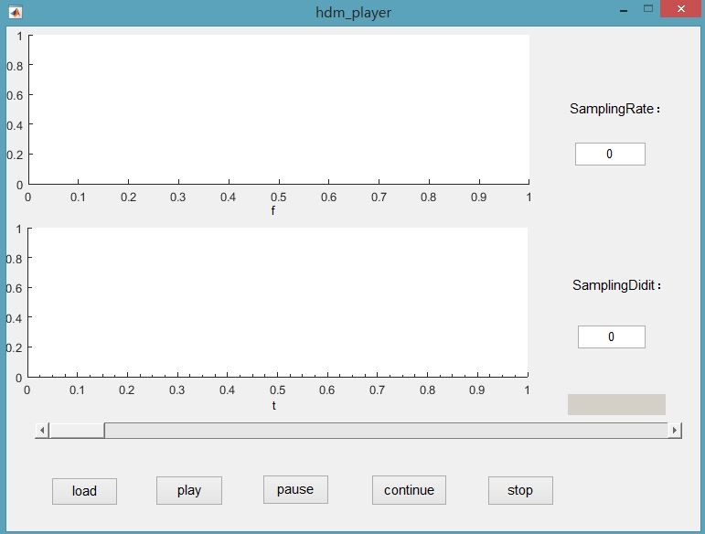
Figure 12 The initial figure
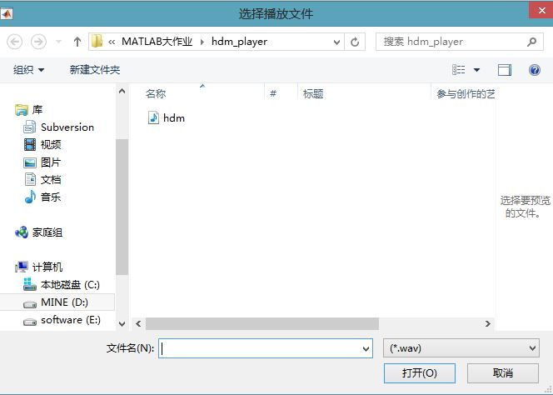
Figure 13 After click load button
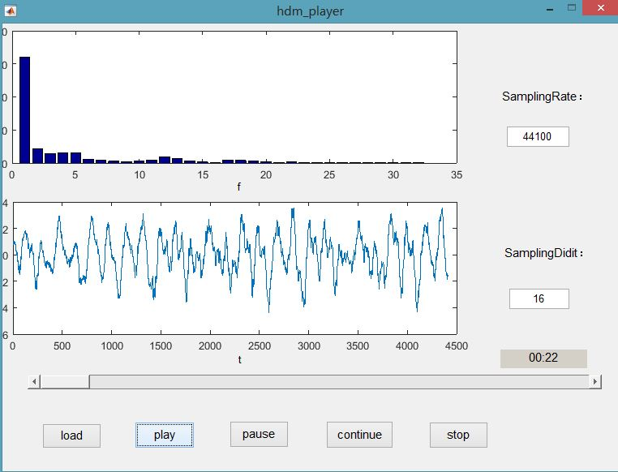
Figure 14 After click the play button
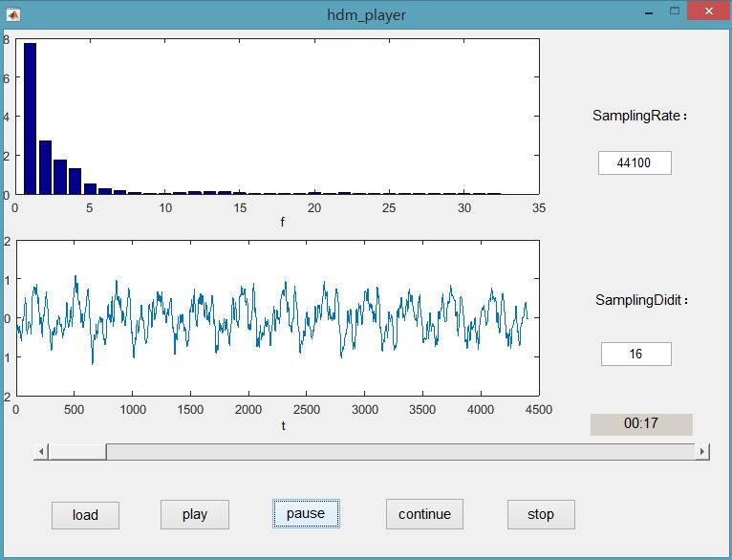
Figure 15 After click the pause button
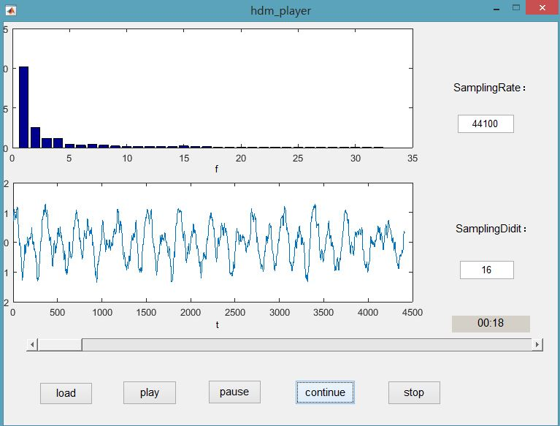
Figure 16 After click the continue button

Project 5
Design and implement an image analyzer with GUI.
(1) The GUI interface is shown as Figure 17.
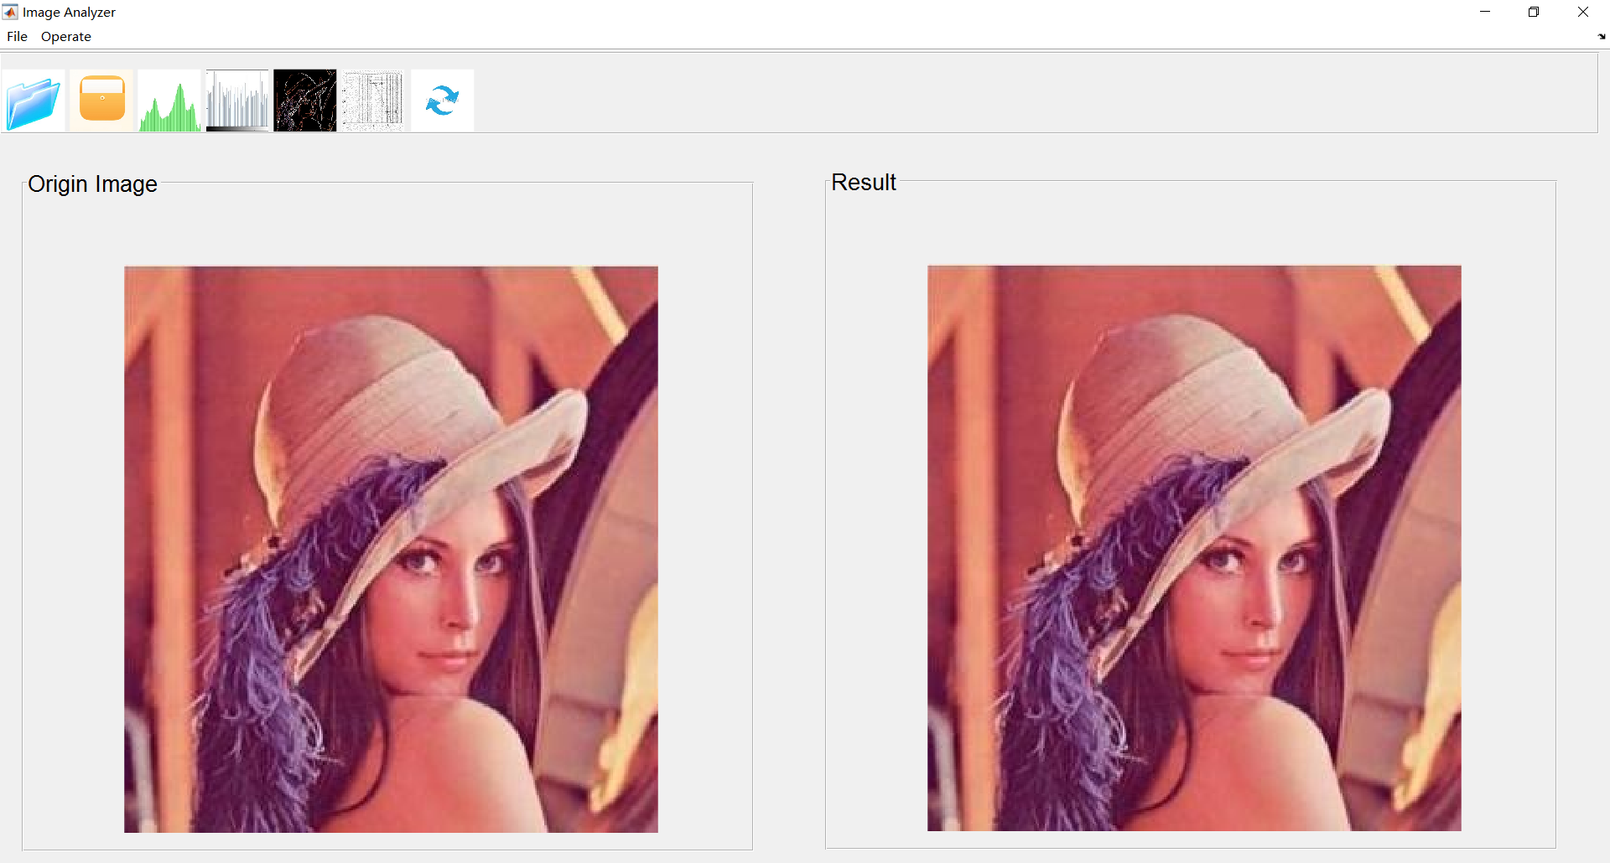
Figure 17 Image Analyzer Interface
(2) The Menus are shown as Figure 18.
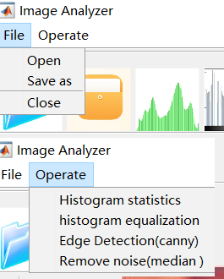
Figure 18 Menu of Image Analyzer Interface
(3) The toolbar are shown as Figure 22.
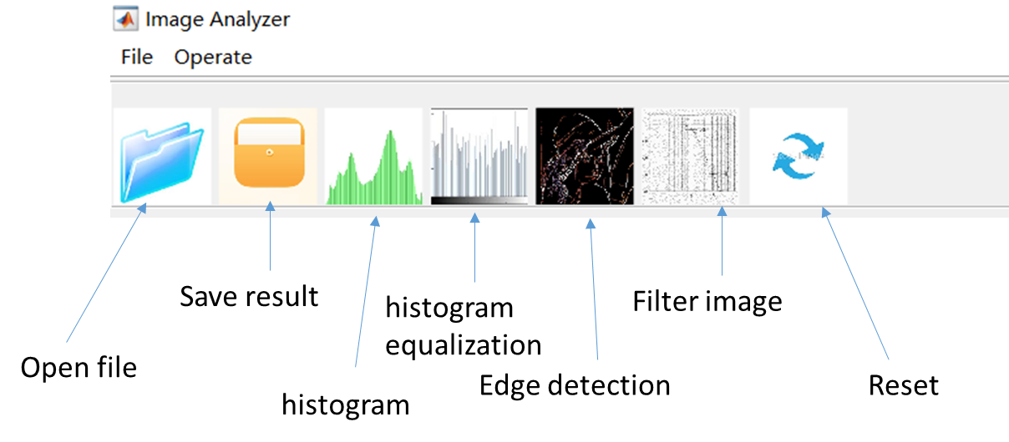
Figure 19 Toolbar of Image Analyzer Interface
(4)Basic functions:
- Open file: open the dialog and update the origin and the result axes.
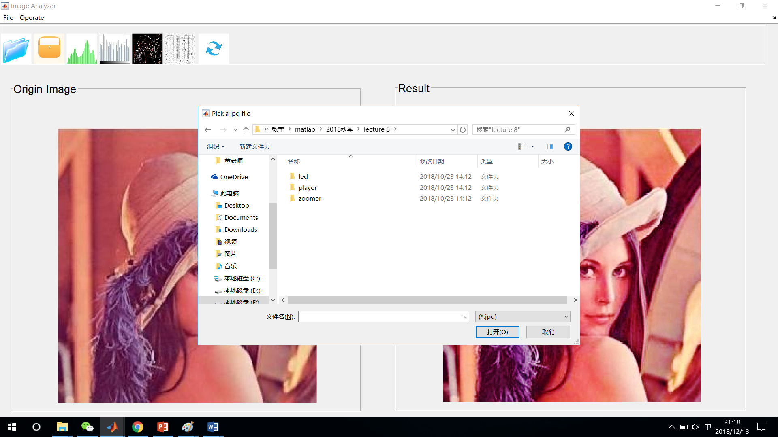
Figure 20 Open file
- Save result: save the output image as jpeg or bmp file.
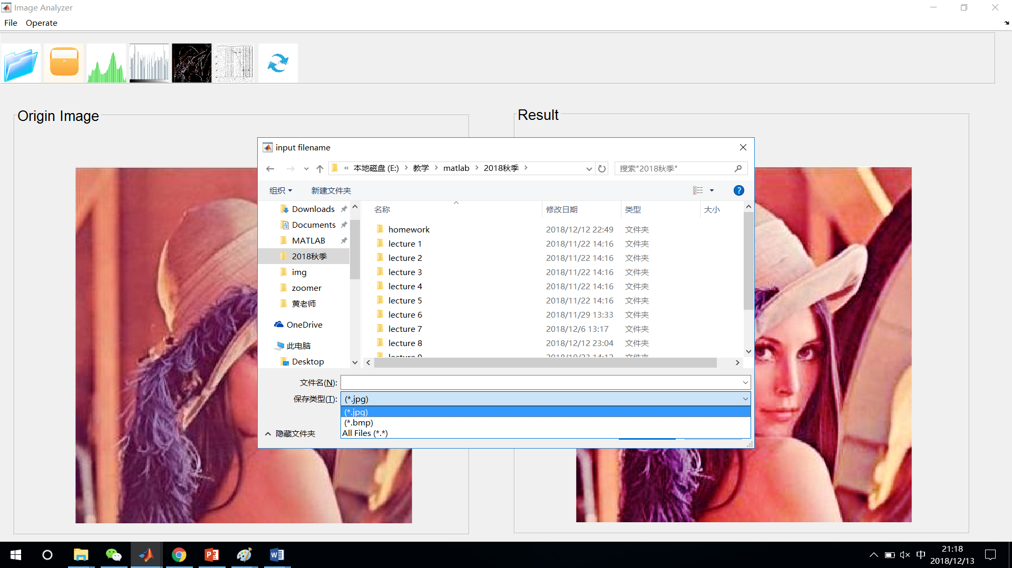
Figure 21 Save result as file
- Histogram: plot the histogram of the origin image.
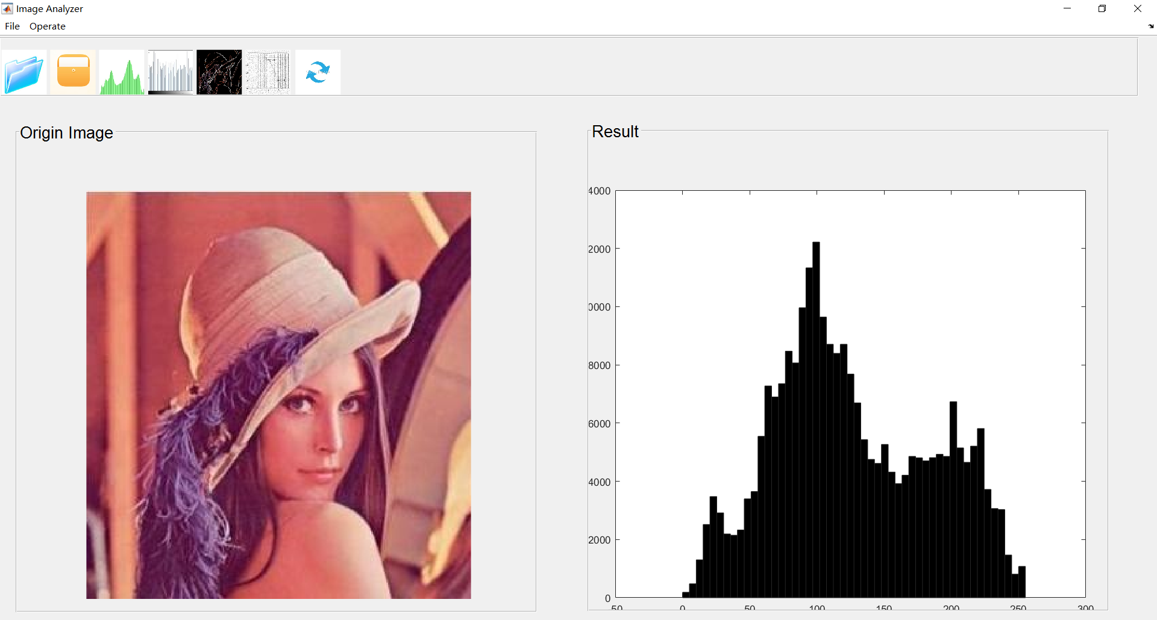
Figure 22 histogram result
- Histogram equalization: process the origin image with histogram equalization method and update the result axes.
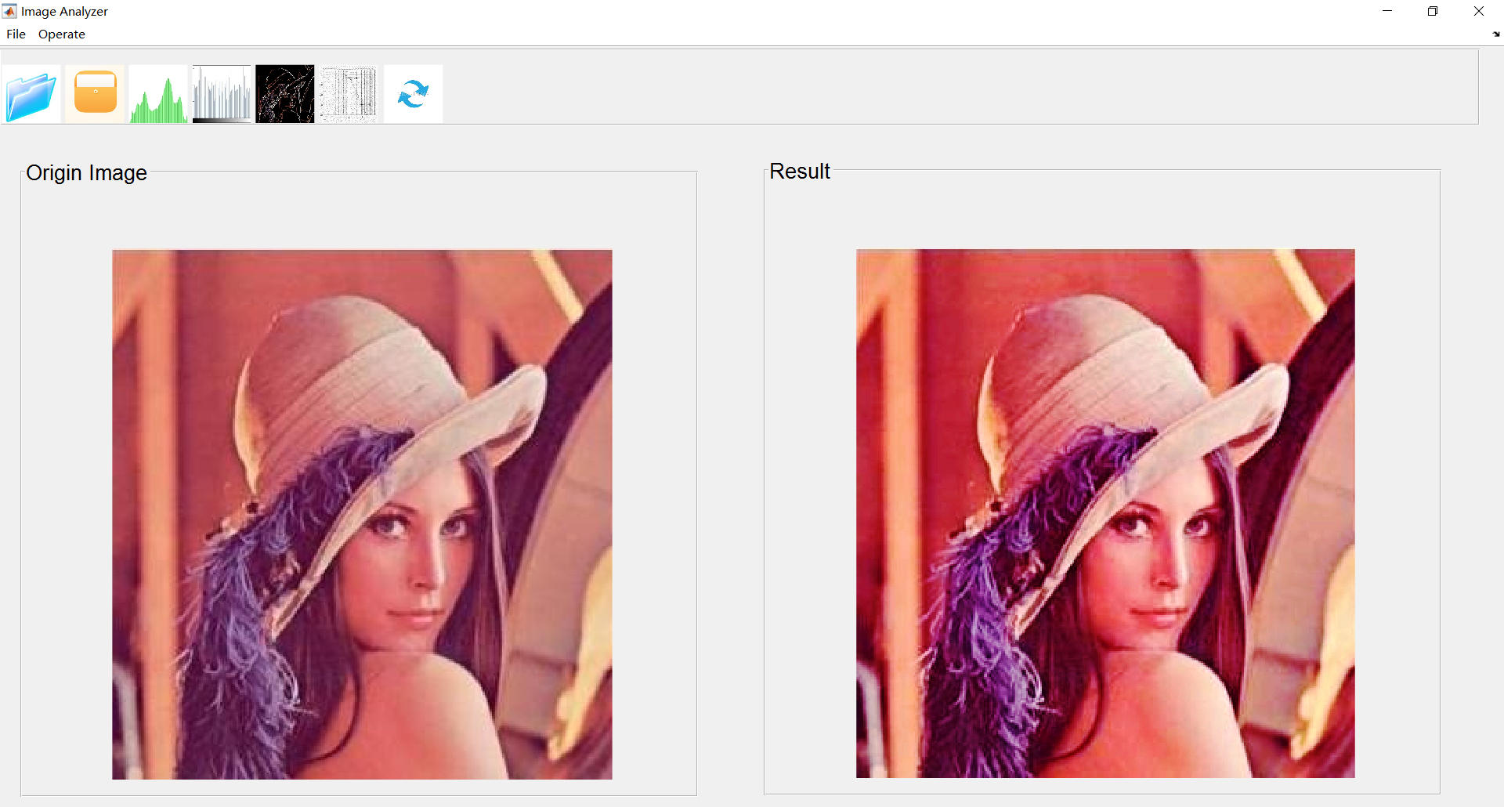
Figure 23 histogram result
- Edge detection: implement the edge detection with canny operator and update the result axes.
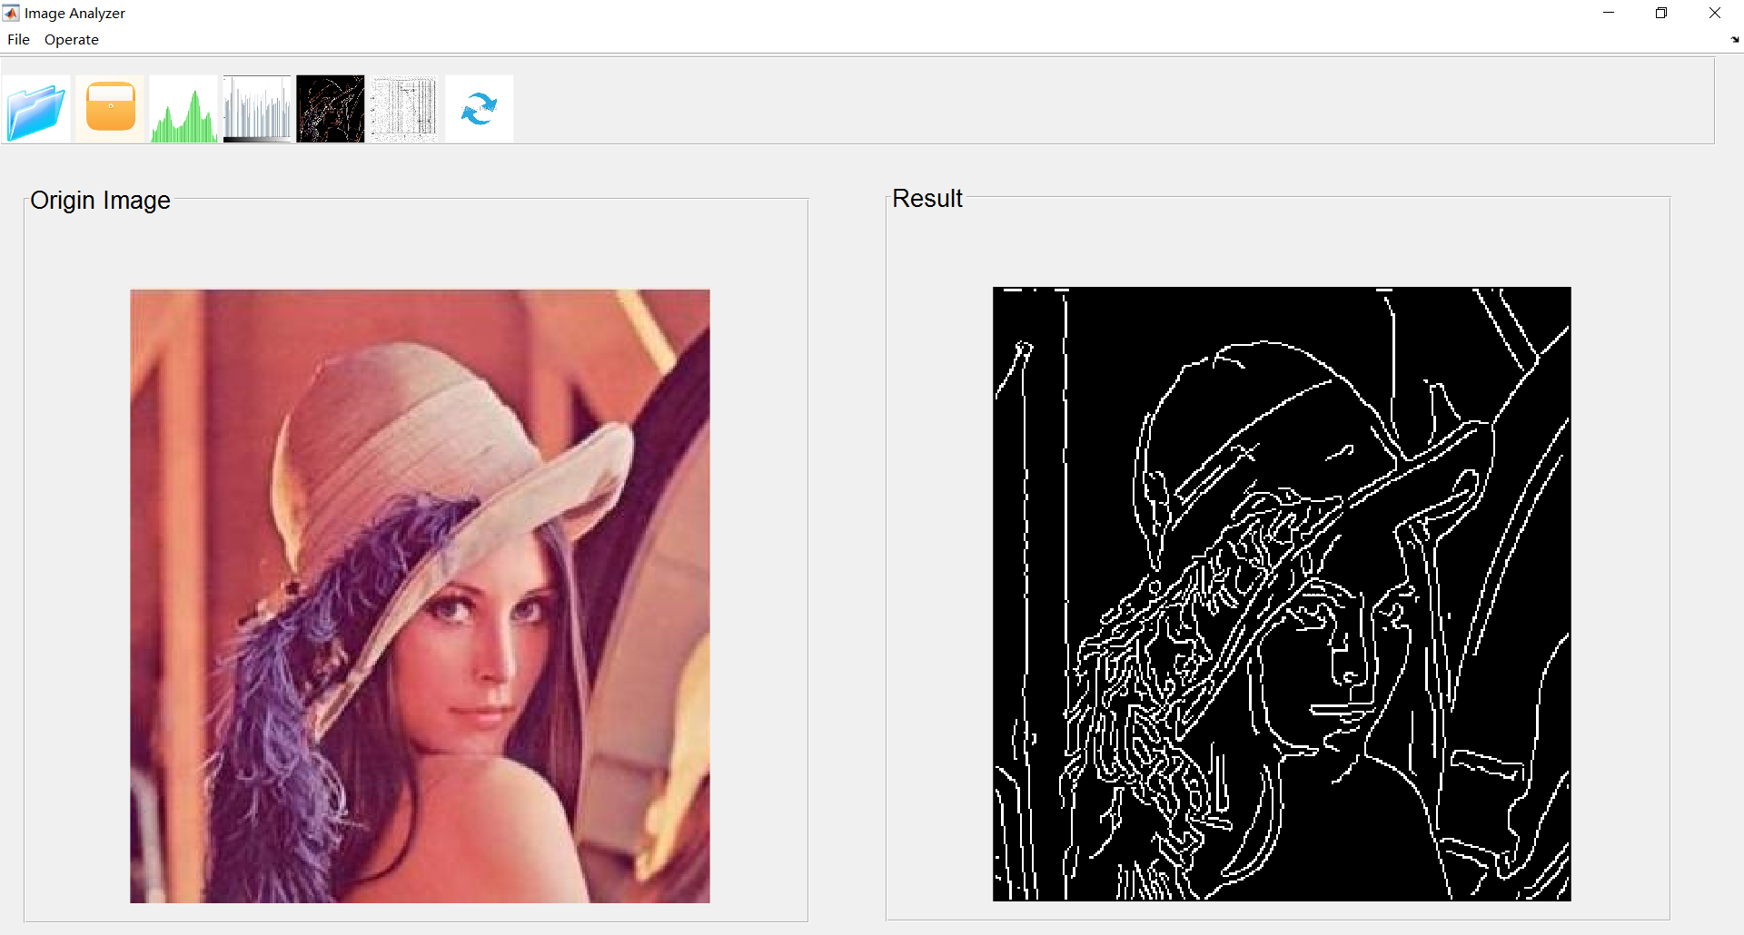
Figure 24 edge detection result
- Filter image: filter the image with the median filter and update the result axes.
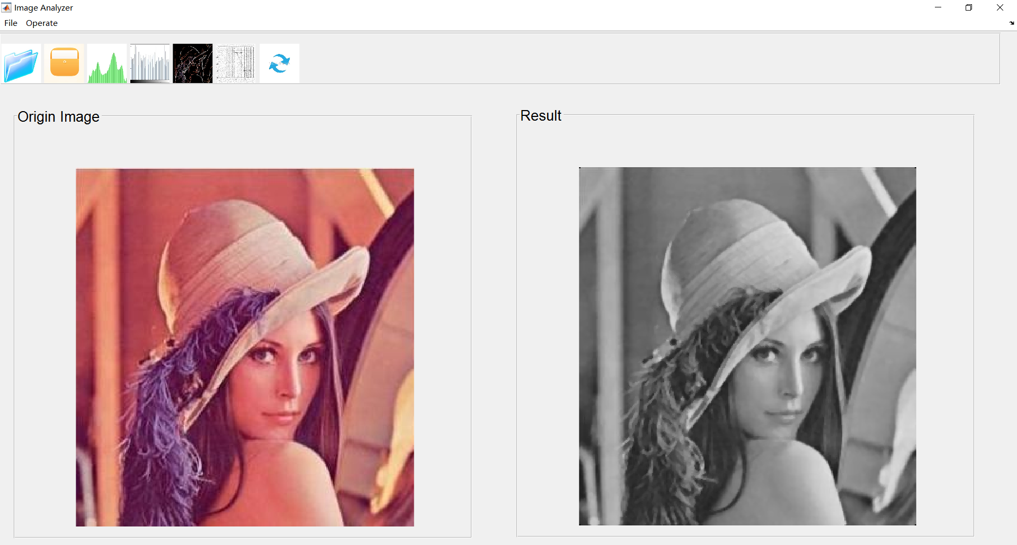
Figure 25 images after median filtering
- Reset: reset the origin and result axes to Lena.

